 | EUROPEAN COMMISSION  DIRECTORATE-GENERAL  INFORMATICS  Information Systems Directorate

European Commission
UC0130 - eTustEx Admin Console - Manage Endpoint Configurations for Message Routing

Date: | 14/06/2018
Version: | 2.901
Authors: | Anamaria BATRINU
Revised by: | Olivier DERVEAU
Approved by:
Public:
Reference Number:
TABLE OF CONTENTS
1. Use-Case Description 8
1.1. Primary Actor 8
1.2. Definitions, Acronyms and Abbreviations 9
1.3. References 9
1.4. Context Diagram 10
1.4.1. CIPA Administration Console 10
1.4.2. Manage Endpoint Configurations for Message Routing module 11
2. Flow of events 11
2.1. Basic Creation Flow 11
2.1.1. User chooses the Create menu action 11
2.1.2. System displays the creation page 12
2.1.3. User enters information and chooses the Save option 12
2.1.4. System creates the Endpoint Configuration 12
2.1.5. User acknowledges the successful message 13
2.1.6. System redisplays the saved Endpoint Configuration in view mode 13
2.1.7. The basic creation flow ends. 13
2.2. Basic search flow 13
2.2.1. User selects the Search Endpoints menu action 14
2.2.2. System displays the "Search Routing Endpoints" page 14
2.2.3. User enters the search criteria 14
2.2.4. The System searches the Endpoint Configurations 14
2.2.5. System displays the Endpoint Configurations found 14
2.2.6. User views the result list 15
2.2.7. The basic search flow ends. 15
2.3. Basic Visualization Flow 15
2.3.1. At 2.2.6, User clicks the active status of an Endpoint Configuration in the list 15
2.3.2. System opens the Endpoint Configuration visualization page (see 7.5 "View Endpoint Configuration" pages): 15
2.3.3. User visualises the details of the Endpoint Configuration: 15
2.3.4. Visualization flow ends. 15
2.4. Basic Modification Flow 15
2.4.1. At 2.3.3, User chooses to edit the Endpoint Configuration 16
2.4.2. System opens the Endpoint Configuration page in edit mode (see 7.5 "View Endpoint Configuration" pages): 16
2.4.3. User makes the changes 16
2.4.4. The system saves the modified Endpoint Configuration 16
2.4.5. User acknowledges the successful message 17
2.4.6. System redisplays the Endpoint Configuration in view mode (see 7.5 "View Endpoint Configuration" pages) 17
2.4.7. The Modification flow ends. 17
2.5. Basic Deletion Flow 18
2.5.1. At 2.3.3., User chooses to delete an Endpoint Configuration 18
2.5.2. System displays a dialog window asking for deletion confirmation 18
2.5.3. User confirms the deletion 18
2.5.4. System deletes the Endpoint Configuration 18
2.5.5. System notifies User of the success of the operation 18
2.5.6. User acknowledges the message 18
2.5.7. The Deletion Flow ends. 18
2.6. Subflows 18
2.6.1. S1: User specifies new authentication / proxy credentials or modifies existing ones 18
2.6.2. S2: User wants to remove the authentication / proxy credentials 19
2.6.3. S3: User specifies existing authentication / proxy credentials 19
2.7. Alternative Flows 19
2.7.1. AC1: at step 2.1.3, User chooses Cancel option 19
2.7.2. AC2: at step 2.1.3, User chooses Clear option 19
2.7.3. AS1: at step 2.2.4, no endpoint configuration found for the specified criteria 20
2.7.4. AM1: at step 2.4.3, User chooses Cancel option 20
2.7.5. AM2: at step 2.4.3, User chooses Reset option 20
2.7.6. A1: at steps 2.1.3, 2.2.3 or 2.4.3, User chooses to search for a Party 20
2.7.7. A2: at steps 2.1.3, 2.2.3 or 2.4.3, User chooses to search for an Interchange Agreement 20
2.7.8. A3: at steps 2.1.3, 2.2.3 or 2.4.3, User chooses to search for a Transaction 20
2.7.9. A4: at steps 2.1.3, 2.2.3 or 2.4.3, User chooses to clear the selected Party, Interchange Agreement or Transaction 21
2.7.10. A5: at steps 2.1.3, 2.2.3 or 2.4.3, User changes the business domain selected in Message Information section 21
2.8. Exceptional Flows 21
2.8.1. E1: at steps 2.1.1, 2.2.1, 2.3.1, 2.4.1 or 2.5.1, User is not authorized for the operation 21
2.8.2. E2: at step 2.1.4 or 2.4.4, Business Rules are not verified 21
2.8.3. E3: at step 2.1.4 or 2.4.4, there is an error when saving the endpoint configuration 21
2.8.4. E4: at step 2.5.4, Business Rules are not verified or an error occurs 21
2.8.5. E5: at any step, a technical error occurs 22
3. Special Requirements 22
3.1. Interface(s) with other Systems 22
3.2. Security Requirements 22
3.3. Other Special Requirement 22
4. Preconditions 22
5. Post conditions 22
6. Additional Information 22
6.1. Includes 22
6.2. Extends 22
7. Mock-up screens 23
7.1. "Create JMS Endpoint Configuration" page 23
7.2. Create Web Service Endpoint Configuration page 24
7.3. Create AMQP Endpoint Configuration page 24
7.4. "Search Endpoint Configurations" page 25
7.5. "View Endpoint Configuration" pages 26
7.5.1. View JMS Endpoint Configuration page 26
7.5.2. View Web Service Endpoint Configuration page 26
7.5.3. View AMQP Endpoint Configuration page 27
7.6. "Modify Endpoint Configuration" pages 28
7.6.1. Modify JMS Endpoint Configuration page 28
7.6.2. Modify Web Service Endpoint Configuration page 28
7.6.3. Modify AMQP Endpoint Configuration page 28
7.7. "Delete Endpoint Configuration" page 29

Document History

Version | Date | Comment | Modified Pages
0.001 | 26/02/2015 | First draft | All
1.000 | 06/03/2015 | First version
1.001 | 26/05/2015 | JIRA CIPADMIN-383: changed source for Message conversion classes | Section Mock-up screens
1.100 | 25/04/2016 | JIRA CIPADMIN-499: The user shall be able to search for credentials (both authentication and proxy) | Where needed
1.101 | 28/04/2016 | JIRA ETRUSTEX-1352: Profile, Interchange Agreement and Transaction should not be mutually excluded in configurations | Where needed
1.102 | 01/06/2016 | JIRA ETRUSTEX-1363:  - revert changes corresponding to ETRUSTEX-1352  - add mandatory business rule for the party field  - add a hint on the party label "Receiver party or its delegated third party"
1.103 | 09/06/2016 | JIRA ETRUSTEX-1442:  - Profile, Transaction and Interchange Agreement must not all be empty | BR130_028 in creation and modification flow
1.2 | 25/07/2016 | JIRA ETRUSTEX-1498:  - ICA search screen should filter the results on the business domain selected in section Message Information  - Added also default business domain for party (already implemented  - Added also filtering on the lists for roles and profiles in transaction and interchange agreement search screens  - Added behaviour when business domain changes in Message Information section | Sections 2.7.6, 2.7.7, 2.7.8.  Section 2.7.10
1.3 | 27/07/2016 | JIRA ETRUSTEX-1560:  - Added BR for username unicity when creating or modifying authentication or proxy credentials (UC130_BR29)
1.4 | 29/07/2016 | JIRA ETRUSTEX-1520 | Credentials popup screens and section S1: User specifies new authentication / proxy credentials or modifies existing ones
2.0 | 01/08/2016 | JIRA ETRUSTEX-1562: add management of AMQP endpoints
2.1 | 19/08/2016 | JIRA ETRUSTEX-1573 | Section 2.6 Subflows:  Removed UC130-BR29  Added UC130_BR31, UC130_BR32, and UC130_BR33  Default type in credentials search popup.
2.2 | 25/10/2016 | JIRA ETRUSTEX-1392 | Where needed
2.3 | 01/12/2016 | JIRA ETRUSTEX-1585 | UC130_BR33 and section 2.6.3 S3: User specifies existing authentication / proxy credentials
2.4 | 24/01/2017 | ETRUSTEX-1937: Reorganizing CIPAdmin user roles
2.5 | 24/01/2017 | ETRUSTEX-2169: Changed business rule 24 | Section 2.5.4 System deletes the Endpoint Configuration
2.6 | 24/07/2017 | ETRUSTEX-2956: unable to change the active flag for an endpoint configuration which has undispatched messages in the routing table | - Section 2.4.4 The system saves the modified Endpoint Configuration: UC130_BR24  - Section 2.5.4 System deletes the Endpoint Configuration: renamed UC130_BR24 to UC130_BR34 to avoid confusion
2.7 | 21/02/2018 | ETRUSTEX-4409: Endpoint authentication and proxy passwords must be saved encrypted | - Section 2.1.4 System creates the Endpoint Configuration  - Section 2.6.1 S1: User specifies new authentication / proxy credentials or modifies existing ones
2.8 | 31/05/2018 | ETRUSTEX-4607: remove the endpoint message type and any specific behaviour related to it | - Wherever needed
2.9 | 04/06/2018 | ETRUSTEX-4608: remove the authorization flag and review behaviour related to it | - Wherever needed
2.901 | 14/06/2018 | ETRUSTEX-4631: As a user I would like to see the endpoint type in the endpoint search results | - 2.2.5 System displays the Endpoint Configurations found  - 2.2.6 User views the result list  - 7.4 "Search Endpoint Configurations" page
2.902 | 02/08/2018 | ETRUSTEX-4600 | Added UC130_BR35 in the following sections:  - 2.1.4 System creates the Endpoint Configuration  - 2.4.4 The system saves the modified Endpoint Configuration

Use-Case Description
This use case depicts the sequence of actions that a user needs in order to create an Endpoint Configuration for message routing. The use case also describes the management actions that correspond to a created Endpoint Configuration, such as Update, Delete, View and Search.
The "Manage Endpoint Configurations" service is exposed on the CIPAdmin module of e-Trustex platform.
In the remainder of the document the CIPAdmin application will be referred to as the System.

Primary Actor
A humain user can access the Manage Endpoint Configurations feature via CIPAdmin interface. For detailed user access rights on each feature option, please see UC 0100 - eTrustEx Admin Console - Authenticate and Authorise User, section 6.3 User Access Rights.
In the remainder of the document, the user will be reffered to as User or by his/her role, in those cases where role specific rules apply.

Definitions, Acronyms and Abbreviations
Acronym, Abbreviation or Definition | Explanation
CIPA | Common Infrastructure for Public Administrations
CIPADMIN | CIPA AdminConsole
ADM | A user having General Administrator role. The General Administrator is the Administrator of the CIPAdmin application.
CBO | A user having Central Business Owner role. The Central Business Owner is responsible for the organization and operation of a business domain and uses CIPA in his business context.
ICA | Interchange Agreement (a logical communication channel which enables communication between two parties).
UC(s) | Use Case(s)

References
Ref. | Reference | Title / description | Version | Date
[R1] | CIPADMIN-VISION | CIPADMIN Vision document | V.61-EN | 18/04/2013

Context Diagram

CIPA Administration Console
The diagram below depicts all the Services available on the CIPA Administration Console for e-TrustEx platform. Depending on the user role, only a subset of those services is exposed on the e-TrustEx Administration Console home page.
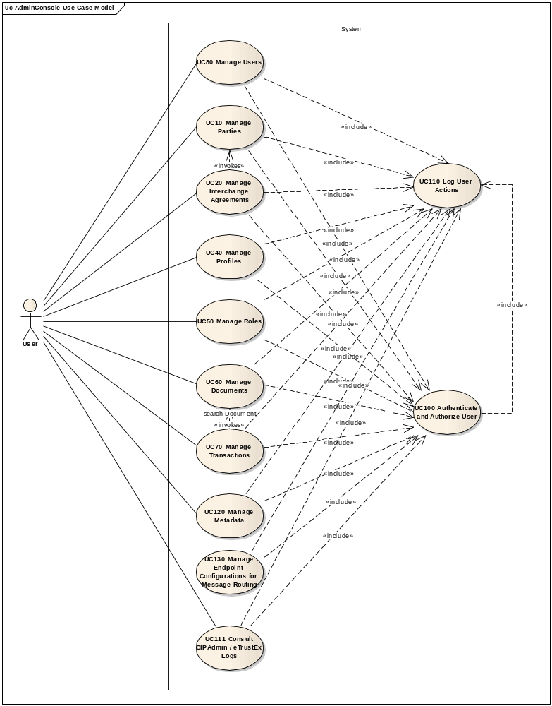

Manage Endpoint Configurations for Message Routing module
The diagram below depicts how this use case interacts with other use cases implemented in the Administration Console.
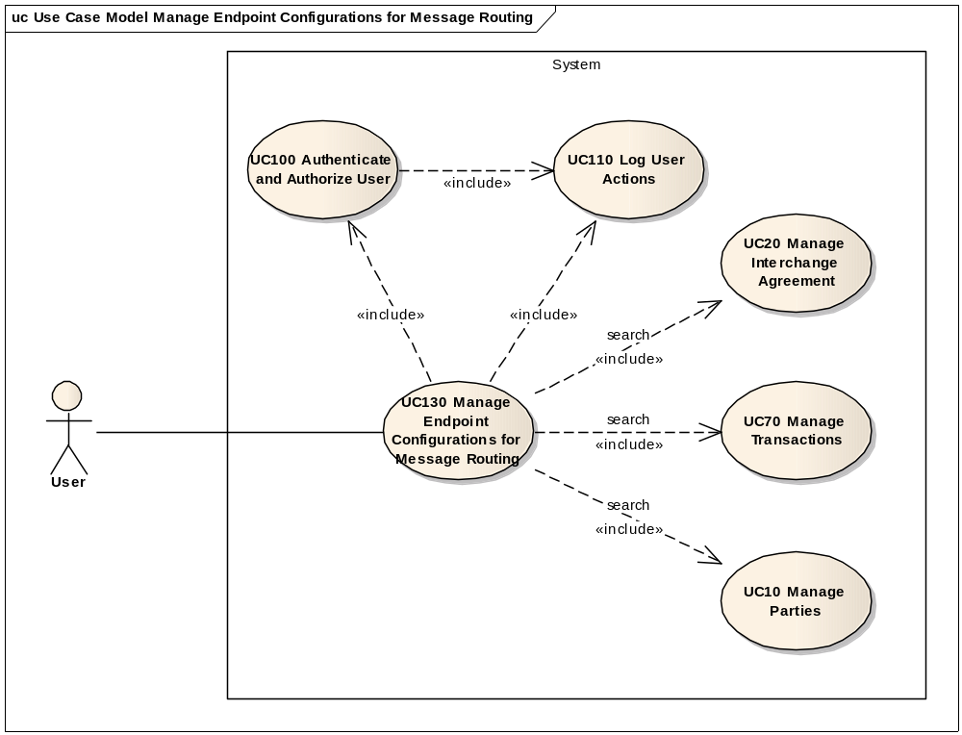

Flow of events
The conventions described in User Interface Generic Conventions document must be applied.

Basic Creation Flow

User chooses the Create menu action
ID | Description
UC130_BR01 | User needs to have the correct access rights in order to access this feature. Please see UC 0100 - eTrustEx Admin Console - Authenticate and Authorise User, section 6.3 User Access Rights for more information.
- For creating a JMS Endpoint Configuration, User selects Business Configuration > Routing Endpoints > Create > JMS Configuration menu path of the e-TrustEx Administration Console home page.
- For creating a Web service Endpoint Configuration, User selects Business Configuration > Routing Endpoints > Create > Web service Configuration menu path of the e-TrustEx Administration Console home page.
- For creating an AMQP Endpoint Configuration, User selects Business Configuration > Routing Endpoints > Create > AMQP Configuration menu path of the e-TrustEx Administration Console home page.

System displays the creation page
- For JMS Endpoint Configuration, System displays the creation page as described in section 7.1 "Create JMS Endpoint Configuration" page.
- For Web service Endpoint Configuration, System displays the creation page as described in section 7.2 Create Web Service Endpoint Configuration page.
- For AMQP Endpoint Configuration, System displays the creation page as described in section 7.3 Create AMQP Endpoint Configuration page.

User enters information and chooses the Save option
In order to specify credentials for endpoint authentication or proxy, follow the steps described in section
- 2.6.1 S1: User specifies new authentication / proxy credentials or
- 2.6.3 S3: User specifies existing authentication / proxy credentials

System creates the Endpoint Configuration
ID | Description
UC130_BR02 | The following fields are mandatory (in general configuration section):  - Is active  - Is using proxy  - Business domain  - Party
UC130_BR03  (JMS specific) | The following fields are mandatory:  - Destination queue  - Is using reply queue  - Initial context factory  - Connection factory  - Provider URL
UC130_BR04 (Web service specific) | The following fields are mandatory:  - Web service URL  - Is message signed  - Is message response signed
UC130_BR30 AMQP specific) | The following fields are mandatory:  - Provider URL
UC130_BR07 | If Is using proxy is set to Yes, the following fields are mandatory:  - proxy Host  - proxy Port  - Proxy credentials  Note that proxy host, port and credentials can be provided even if the endpoint is not marked as using a proxy.
UC130_BR35 | If proxy credentials are filled in, the proxy host and port must also be filled in.
UC130_BR11 | The specified business domain shall be one of the business domains for which the user is configured.
UC130_BR12 | Profile, Transaction and Interchange Agreement are mutually exclusive.
UC130_BR28 | Profile, Transaction and Interchange Agreement must not all be empty.
UC130_BR13 | When saving the configuration, the leading and trailing spaces of the fields are ignored.
UC130_BR14 | If Profile is specified, it shall pertain to the current business domain selected in the Business domain field of Message information section. If no such business domain is selected, the profile shall pertain to the current selected business domain of the user.
UC130_BR15 | If Interchange Agreement is specified, it shall pertain to the current business domain selected in the Business domain field of Message information section. If no such business domain is selected, the interchange agreement shall pertain to the current selected business domain of the user.  Note: The business domain of an interchange agreement can be determined by looking at the business domain of one of the parties involved in the interchange agreement.
UC130_BR16 | The specified Party shall pertain to the current business domain selected in the Business domain field of Message information section.

- System validates the page according to the business rules.
- System saves the Endpoint configuration (the general endpoint and the specific endpoint which is then linked to the general one) and any other entities that need to be saved (like authentication and proxy credentials). Note: The authentication and proxy passwords shall be saved encrypted.
- System logs the successful creation: include use case Log CIPAdmin User Actions
- System informs the user about the success of the operation

User acknowledges the successful message

System redisplays the saved Endpoint Configuration in view mode
- System goes to step 2.3.2 in 2.3 Basic Visualization Flow.

The basic creation flow ends.

Basic search flow
ID | Description
UC130_BR01 | User needs to have the correct access rights in order to access this feature. Please see UC 0100 - eTrustEx Admin Console - Authenticate and Authorise User, section 6.3 User Access Rights for more information.

User selects the Search Endpoints menu action
User selects the Search option by following Business Configuration => Routing endpoints menu path of the e-TrustEx Administration Console home page.

System displays the "Search Routing Endpoints" page
System displays the search page as described in paragraph 7.4 "Search Endpoint Configurations" page.

User enters the search criteria
- User enters one or more search criteria. A search criterion left empty means the concerned field will not be taken into account. The user can search by:
- Endpoint type
- Active status

- Authentication username
- Proxy username
- Message business domain, profile, transaction, interchange agreement and party for which the endpoint is configured
- User activates the search button.

The System searches the Endpoint Configurations
ID | Description
UC130_BR17 | If the endpoint type is not mentioned, all endpoints (JMS, Web service, and AMQP) are searched for.
UC130_BR18 | A field left empty or containing only spaces is not taken into account during the search.
UC130_BR19 | Character case is ignored.
UC130_BR20 | Trailing and leading spaces are ignored.
UC130_BR21 | Field value can contain a partial match (free text fields).
UC130_BR22 | If a single search field is filled in, it needs to contain at least 2 characters (free text fields).
UC130_BR23 | At least one search field should be filled in.
The system searches the endpoint configurations that satisfy all the entered criteria.

System displays the Endpoint Configurations found
The system displays the list of Endpoint Configurations coresponding to the search criteria, showing the following information:
  - Endpoint type

  - Active status
  - Authentication username
  - Proxy username
  - Business domain
  - Profile
  - Transaction name and version
  - Interchange Agreement id
  - Party

User views the result list
- User can view the details of an Endpoint Configuration by clicking on its endpoint type in the results list (see 2.3 Basic Visualization Flow)
- User can launch a new search

The basic search flow ends.

Basic Visualization Flow
ID | Description
UC130_BR01 | User needs to have the correct access rights in order to access this feature. Please see UC 0100 - eTrustEx Admin Console - Authenticate and Authorise User, section 6.3 User Access Rights for more information.

At 2.2.6, User clicks the endpoint type of an Endpoint Configuration in the list

System opens the Endpoint Configuration visualization page (see 7.5 "View Endpoint Configuration" pages):
- System reads the data
- System loads data on the corresponding screen (JMS, Web service, or AMQP Endpoint specific)
- All fields are read only
- "Cancel", "Edit" and "Delete" buttons are made available

User visualises the details of the Endpoint Configuration:
- User can return to the result list by choosing "Cancel", the view flow ends and basic search flow restarts at 2.2.6
- User can choose to edit or to delete an Endpoint Configuration (see 2.4 Basic Modification Flow and 2.5 Basic Deletion Flow)

Visualization flow ends.

Basic Modification Flow
ID | Description
UC130_BR01 | User needs to have the correct access rights in order to access this feature. Please see UC 0100 - eTrustEx Admin Console - Authenticate and Authorise User, section 6.3 User Access Rights for more information.

At 2.3.3, User chooses to edit the Endpoint Configuration

System opens the Endpoint Configuration page in edit mode (see 7.5 "View Endpoint Configuration" pages):
- All fields can be modified;
- "Cancel", "Reset" and "Save" options are present.

User makes the changes
- User makes the desired changes
- User chooses the save option

The system saves the modified Endpoint Configuration
ID | Description
UC130_BR02 | The following fields are mandatory:  - Is active  - Is using proxy  - Business domain  - Party
UC130_BR03  (JMS specific) | The following fields are mandatory:  - Destination queue  - Is using reply queue  - Initial context factory  - Connection factory  - Provider URL
UC130_BR04 (Web service specific) | The following fields are mandatory:  - Web service URL  - Is message signed  - Is message response signed
UC130_BR30 (AMQP specific) | The following fields are mandatory:  Provider URL
UC130_BR07 | If Is using proxy is set to Yes, the following fields are mandatory:  - proxy Host  - proxy Port  - Proxy credentials  Note that proxy host, port and credentials can be provided even if the endpoint is not marked as using a proxy.
UC130_BR35 | If proxy credentials are filled in, the proxy host and port must also be filled in.
UC130_BR11 | If a business domain is specified, it shall be one of the business domains for which the user is configured.
UC130_BR12 | Profile, Transaction and Interchange Agreement are mutually exclusive.
UC130_BR28 | Profile, Transaction and Interchange Agreement must not all be empty.
UC130_BR13 | When saving the configuration, the leading and trailing spaces of the fields are ignored.
UC130_BR14 | If Profile is specified, it shall pertain to the current business domain selected in the Business domain field of Message information section. If no such business domain is selected, the profile shall pertain to the current selected business domain of the user.
UC130_BR15 | If Interchange Agreement is specified, it shall pertain to the current business domain selected in the Business domain field of Message information section. If no such business domain is selected, the profile shall pertain to the current selected business domain of the user.  Note: The business domain of an interchange agreement can be determined by looking at the business domain of one of the parties involved in the interchange agreement.
UC130_BR16 | The specified Party shall pertain to the current business domain selected in the Business domain field of Message information section.
UC130_BR24 | If there is at least one message that has not yet been successfully dispatched, the endpoint configuration cannot be changed except for the activate flag.  If the endpoint is inactivated no more messages can be dispatched to it.
UC130_BR25 | Deleting the authentication or proxy credentials from the endpoint configuration shall also remove them from the System (prevention of orphan records) if there are no other endpoints using them.

- The system validates the page according to the business rules.
- The system saves the Endpoint Configuration and the authentication and proxy credentials if any provided.
- System logs the successful modification: include use case Log CIPAdmin User Actions
- The System informs the user about the success of the operation

User acknowledges the successful message

System redisplays the Endpoint Configuration in view mode (see 7.5 "View Endpoint Configuration" pages)

The Modification flow ends.

Basic Deletion Flow
ID | Description
UC130_BR01 | User needs to have the correct access rights in order to access this feature. Please see UC 0100 - eTrustEx Admin Console - Authenticate and Authorise User, section 6.3 User Access Rights for more information.

At 2.3.3., User chooses to delete an Endpoint Configuration

System displays a dialog window asking for deletion confirmation

User confirms the deletion
If user chooses to cancel the deletion, he/she is returned to the visualization page (2.3.3.).

System deletes the Endpoint Configuration
ID | Description
UC130_BR34 | If there is at least one record in the message routing table (meaning there are messages in the system that were dispatched or will be dispatched to this endpoint), the endpoint shall not be deleted.  Neverthless the endpoint can be inactivated by using the basic modification flow and changing the active flag from Yes to No. If the endpoint is inactivated no more messages can be dispatched to it.
- System verifies the business rules
- System deletes the Endpoint Configuration (generic and specific endpoint configurations)
- System logs the successful deletion: include use case Log CIPAdmin User Actions

System notifies User of the success of the operation

User acknowledges the message

The Deletion Flow ends.

Subflows

S1: User specifies new authentication / proxy credentials or modifies existing ones
- User selects the new / edit option of the corresponding credentials field
- System opens a popup window as shown in section 7.1 "Create JMS Endpoint Configuration" page. The credentials popup must display the recommended guidelines for passwords.
- User enters the information and chooses Ok option
ID | Description
UC130_BR26 | The following fields are mandatory:  - Username  - Password  - Confirm password
UC130_BR27 | Password and Confirm password values must be identical.  Note: The passwords shall be saved encrypted.
UC130_BR31 | For proxy credentials, username must be unique per proxy host and proxy port.
UC130_BR32 | For authentication credentials, username must be unique per  - Provider URL for JMS endpoints  - Webservice URL for WebService endpoints  - AMQP provider URL for AMQP endpoints
UC130_BR33 | When saving, the credentials type is always mandatory:  - PROXY for proxy credentials  - for authentication credentials it depends on the endpoint type:  - WS for web services authentication credentials  - JMS for JMS authentication credentials  - AMQP for AMQP authentication credentials
- System verifies the business rules and returns the username to the parent window, filling it in the corresponding field.

S2: User wants to remove the authentication / proxy credentials
- User selects the remove option of the corresponding credentials field
- System empties the username and password fields.
- Saving the Endpoint will lead to application of UC130_BR25

S3: User specifies existing authentication / proxy credentials
- User selects the search option of the corresponding credentials field
- System opens a Credentials Search Popup: include Search Credentials UC (credentials type will be defaulted to PROXY, if user is searching for proxy credentials, and to JMS, WS or AMQP if user is searching for authentication credentials, depending on the endpoint type of the endpoint currently configured)
- System fills in the read-only input text with the username of the credentials returned at previous step.

Alternative Flows

AC1: at step 2.1.3, User chooses Cancel option
- System disregards all information provided by User
- System closes the page
- System redirects the user to CIPAdmin home page
- Use Case ends

AC2: at step 2.1.3, User chooses Clear option
- Systems disregards all information provided by the user
- Alternate flow ends and basic creation flow restarts at 2.1.2.

AS1: at step 2.2.4, no endpoint configuration found for the specified criteria
- The system notifies the user that no endpoints configurations have been found
- Alternate flow ends and basic search flow restarts at 2.2.3

AM1: at step 2.4.3, User chooses Cancel option
- System disregards all information provided by User
- System closes the page
- Alternate flow ends and basic flow restarts at 2.3.2 (visualization page).

AM2: at step 2.4.3, User chooses Reset option
- Systems disregards all information provided by the user
- Alternate flow ends and basic modification flow restarts at 2.4.2.

A1: at steps 2.1.3, 2.2.3 or 2.4.3, User chooses to search for a Party
- System opens a Party Search Popup: include section 2.2. Basic Search Flow (from step 2.2.2. System displays the Search Party page) of Manage Party Use Case.
Displaying the criteria: The business domain in the party search criteria is defaulted to the business domain selected in the Message Information section. If no business domain selected in the Message information section, than it is defaulted to the currently selected business domain (found in the application header).
- System fills in the read-only input text with the party name of the party returned at previous point
- Alternate flow ends and basic flow continues at 2.1.3, 2.2.3, respectively 2.4.3.

A2: at steps 2.1.3, 2.2.3 or 2.4.3, User chooses to search for an Interchange Agreement
- System opens an Interchange Agreement Search Popup: include section 2.3. Basic Search Flow (from step 2.3.2. System displays the Search Interchange Agreement page) of Manage Interchange Agreement Use Case.
Displaying the criteria: The list of profiles displayed in the interchange agreement search criteria must be filtered on the business domain selected in the Message Information section. If no business domain selected in the Message information section, than the filtering is done on the currently selected business domain (found in the application header). Also the list of party roles must be filtered in order to only show the roles that correspond to the transactions of the profiles pertaining to the concerned business domain.
Filtering the results: The search results must be filtered on the business domain selected in the Message Information section. If no business domain selected in the Message information section, than the filtering is done on the currently selected business domain (found in the application header).
- System fills in the read-only input text with the interchange agreement id of the interchange agreement returned at previous step
- Alternate flow ends and basic flow continues at 2.1.3, 2.2.3, respectively 2.4.3.

A3: at steps 2.1.3, 2.2.3 or 2.4.3, User chooses to search for a Transaction
- System opens a Transaction Search Popup: include section 2.3. Basic Search Flow (from step 2.2.2. System displays the Search Transaction page) of Manage Transaction Use Case. Displaying the criteria: The list of profiles displayed in the transaction search criteria must be filtered on the business domain selected in the Message Information section. If no business domain selected in the Message information section, than the filtering is done on the currently selected business domain (found in the application header). Also the lists of sender and receiver roles must be filtered in order to only show the roles that correspond to the transactions of the profiles pertaining to the concerned business domain.
Filtering the results: The search results must be filtered so that only the transactions pertaining to profiles in correlation with the concerned business domain are shown.
- System fills in the read-only input text with the name and version of the transaction returned at previous step
- Alternate flow ends and basic flow continues at 2.1.3, 2.2.3, respectively 2.4.3.

A4: at steps 2.1.3, 2.2.3 or 2.4.3, User chooses to clear the selected Party, Interchange Agreement or Transaction
- User chooses the clear button next to the field he / she wants to clear
- System removes the selected value from the read only field
- Alternate flow ends and basic flow continues at 2.1.3, 2.2.3, respectively 2.4.3.

A5: at steps 2.1.3, 2.2.3 or 2.4.3, User changes the business domain selected in Message Information section
- User changes the business domain selected in Message Information Section
- System refreshes the profile list (only profiles pertaining to the selected business domain will be displayed) and clears the current profile selection if it does not appear in the refreshed list.
- System clears the transaction, interchange agreement and party fields if they do not belong to the selected business domain
- Alternate flow ends and basic flow continues at 2.1.3, 2.2.3, respectively 2.4.3.

Exceptional Flows

E1: at steps 2.1.1, 2.2.1, 2.3.1, 2.4.1 or 2.5.1, User is not authorized for the operation
Include the steps in section 2.4.1 of Authenticate and Authorise User Use Case.

E2: at step 2.1.4 or 2.4.4, Business Rules are not verified
- System logs the error: include use case Log CIPAdmin User Actions
- The system highlights the field(s) in error
- The System displays the error messages.
- Flow restarts at 2.1.3, respectively 2.4.3.

E3: at step 2.1.4 or 2.4.4, there is an error when saving the endpoint configuration
- System logs the error: include use case Log CIPAdmin User Actions
- The system informs the user about the error.
- Use case ends.

E4: at step 2.5.4, Business Rules are not verified or an error occurs
- System logs the error: include use case Log CIPAdmin User Actions
- The system informs the user about the error.
- Deletion flow ends.

E5: at any step, a technical error occurs
- System logs the error: include use case Log CIPAdmin User Actions
- The system informs the user about the error.
- Use case ends.

Special Requirements

Interface(s) with other Systems

Security Requirements

Other Special Requirement

Preconditions
- User must be registered user of CIPAdmin tool
- User must be logged in & successfully authenticated on the e-TrustEx Admin Console (see UC 0100 - eTrustEx Admin Console - Authenticate and Authorise User)

Post conditions
- [Success] The Endpoint Configuration has been successfully created / modified / deleted.
- [Failure] The System logs the failure reason and the context, the use case is aborted and the primary actor has been notified of the reasons.

Additional Information

Includes
- For operation authorization: UC 0100 - eTrustEx Admin Console - Authenticate and Authorise User
- For logging: UC 0110 - eTrustEx Admin Console - Log CIPAdmin User Actions
- For searching or visualizing a document: UC 0010 - eTrustEx Admin Console - Manage Parties
- For searching or visualizing an interchange agreement: UC 0020 - eTrustEx Admin Console - Manage Interchange Agreements
- For searching or visualizing a transaction: UC 0070 - eTrustEx Admin Console - Manage Transaction
- For searching credentials: UC 180 - eTrustEx Admin Console - Search Credentials

Extends

Mock-up screens

"Create JMS Endpoint Configuration" page
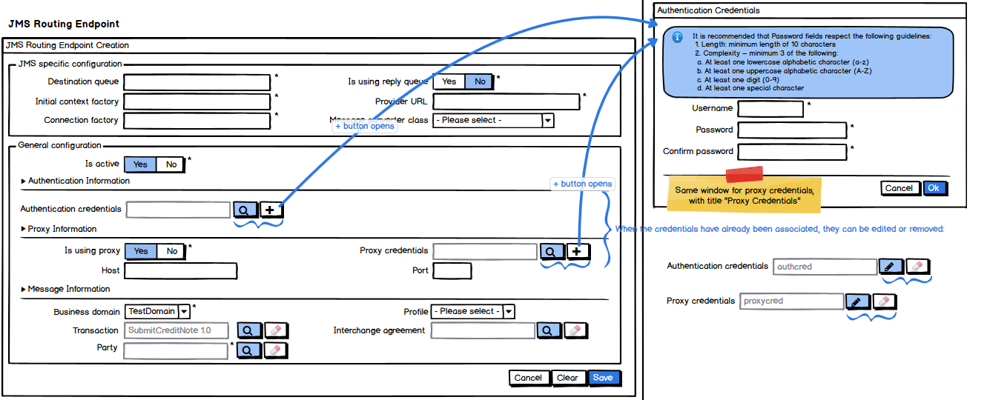
- The System fills in

  - The Message converter class list is populated by the System and there is no default selection (JMS specific).
  - The Business domain list with the business domains the user is configured with, ordered in ascendant alphabetical order and ignoring case. Selected by default: no default selection.
  - The Profile list with the profiles corresponding to the business domain selected in the Business domain list, or, if none selected, with the profiles corresponding to to the user selected business domain, ordered in ascendant alphabetical order and ignoring case. Selected by default: no default selection.
- The Transaction, Interchange agreement and Party fields are read only. They are automatically filled in by the system when user selects a transaction, interchange agreement or party in the corresponding search page that can be accessed via the search button next to the concerned field. The transaction field is filled in with the name and version of the transaction.
- The Authentication credentials and Proxy credentials are read only. They are automatically filled in by the system with the credentials username when user creates, modifies or search a credential using the credentials popup opened via the New, Edit or Search options. The credentials popup contains the password recommendations.
- Party label should show a tooltip on mouse-over: «Receiver party or its delegated third party», to avoid user confusion.
- Default values for flags:
  - Is active: Yes

  - Is using proxy: No
  - Is using reply queue: No (JMS specific)
- The clear button next to each read only field, gives the option to clear the content of the corresponding field
- Starred fields are mandatory.
- Clear, Cancel and Save options are present.

Create Web Service Endpoint Configuration page
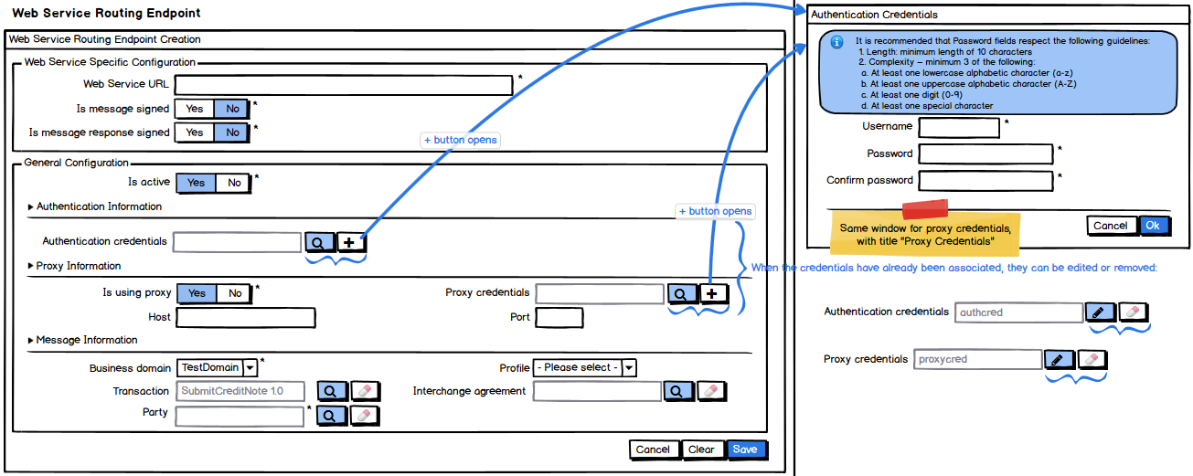
See points (1) to (8) from section 7.1 "Create JMS Endpoint Configuration" page.
Default values for specific web services flags (note that JMS specific flag from previous section shall not be taken into account for this section):
- Is message signed: No
- Is message response signed: No

Create AMQP Endpoint Configuration page
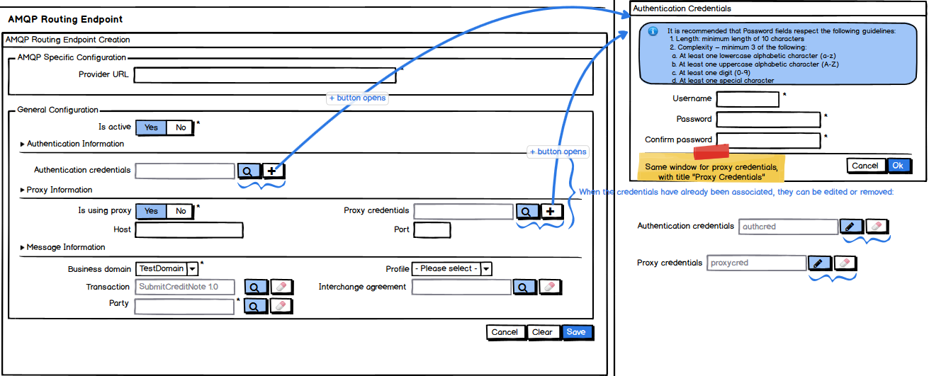
See points (1) to (8) from section 7.1 "Create JMS Endpoint Configuration" page.

"Search Endpoint Configurations" page
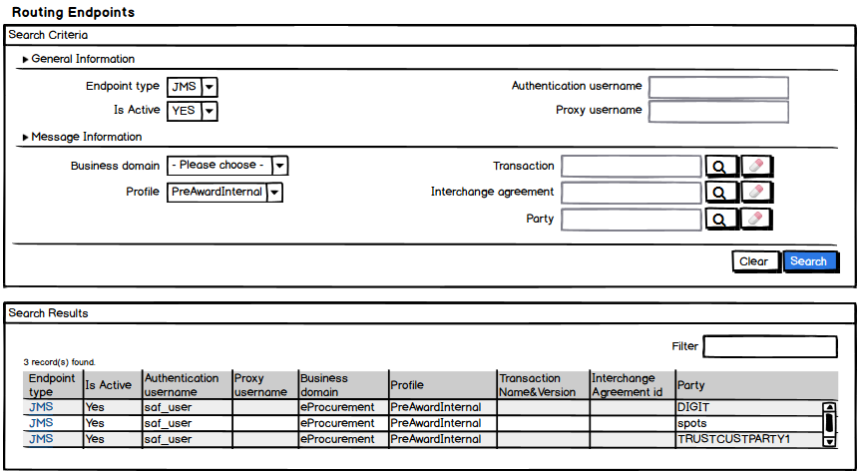
- Search Criteria section
  - See points (1) to (2) from section 7.1 "Create JMS Endpoint Configuration" page.
  - Endpoint type list support the values JMS, Web services and AMQP. Selected by default: no default selection.
  - Is active list supports the values Yes and No. Selected by default: no default selection.
  - There are no default selections for Business domain and Profile
  - Clear and Search options are present.
- Search Results section
  - The number of results found is shown to the user
  - A filter on the results is also made available to the user
  - The results list shows the following information
    - The endpoint type

    - Active status of the endpoint
    - The authentication username
    - The proxy username
    - The business domain for which the endpoint is configured
    - The profile for which the endpoint is configured
    - The name and version of the transaction for which the endpoint is configured
    - The id of the interchange agreement for which the endpoint is configured
  - No ordering is imposed on the results list.
  - The endpoint type in the results list is interactive, and clicking on it will show the endpoint details

"View Endpoint Configuration" pages

View JMS Endpoint Configuration page
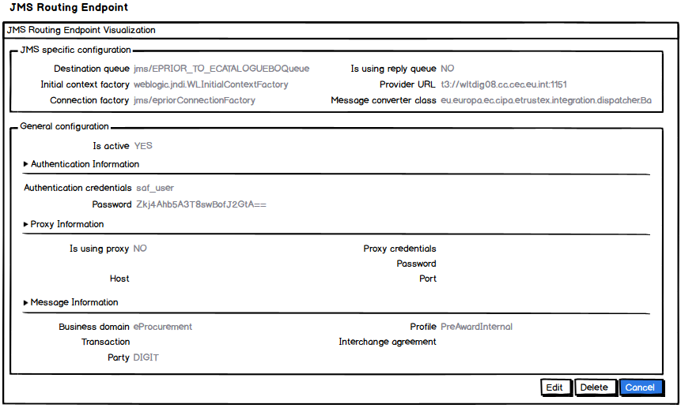
As a general rule, if there is any information that is too long, it should not be truncated. The user shall be able to see the information entirely, so a textarea with adaptive height shall be used where needed.

View Web Service Endpoint Configuration page
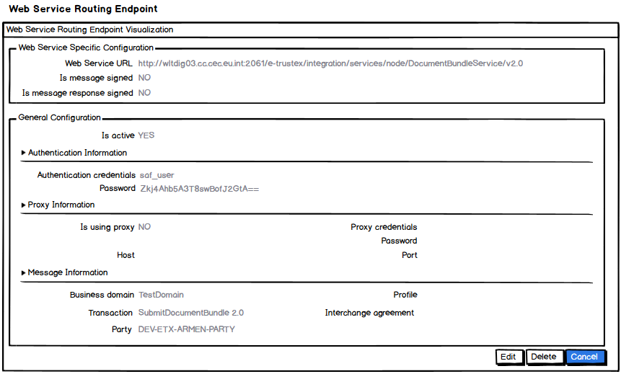

View AMQP Endpoint Configuration page
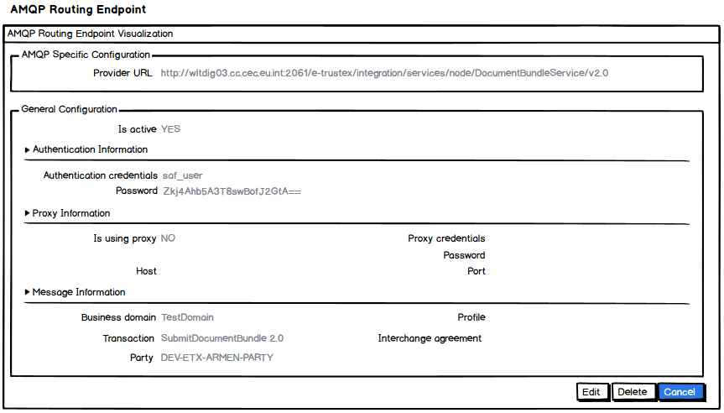
For JMS Endpoint Configurations, the System shows
- The name of the destination queue
- If a reply queue is used or not
- The initial context factory to be used for accessing the naming service
- The connection factory to be used
- The URL of the JMS provider
- The converter class used for converting the message before sending it
For Web services Configurations, the System shows
- The URL of the web service
- If message is signed or not
- If the message response shall be signed or not
For AMQP Configurations, the System shows
- The provider URL
For all configurations (JMS, Web services and AMQP):

- The active status of the endpoint

- The authentication username and password
- If endpoint is using proxy or not
- The proxy username and password
- The proxy host and port
- The business domain, profile, transaction (name and version), interchange agreement and party for which the endpoint is configured
- Edit, Delete and Cancel options are present.

"Modify Endpoint Configuration" pages

Modify JMS Endpoint Configuration page
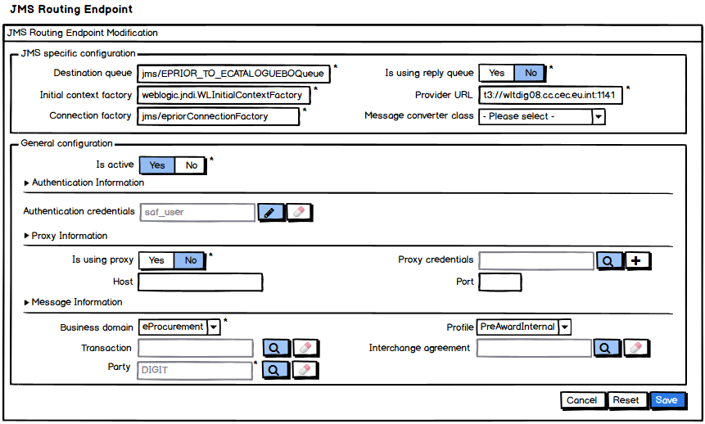

Modify Web Service Endpoint Configuration page
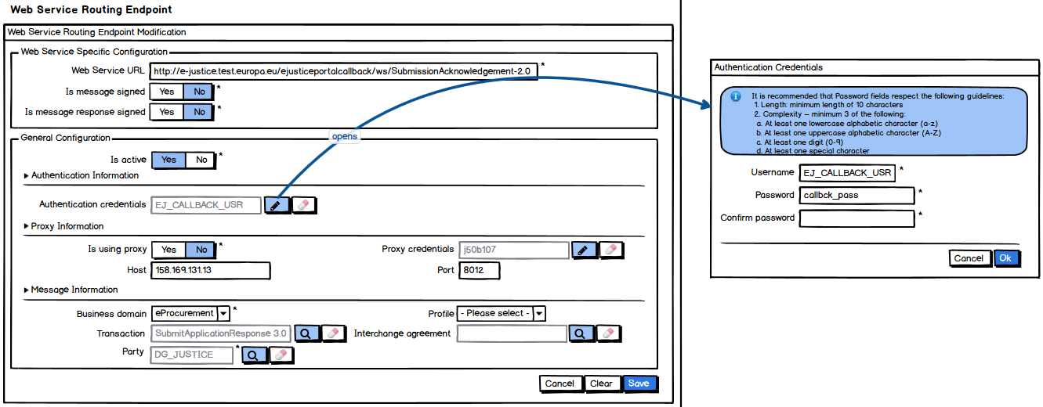

Modify AMQP Endpoint Configuration page
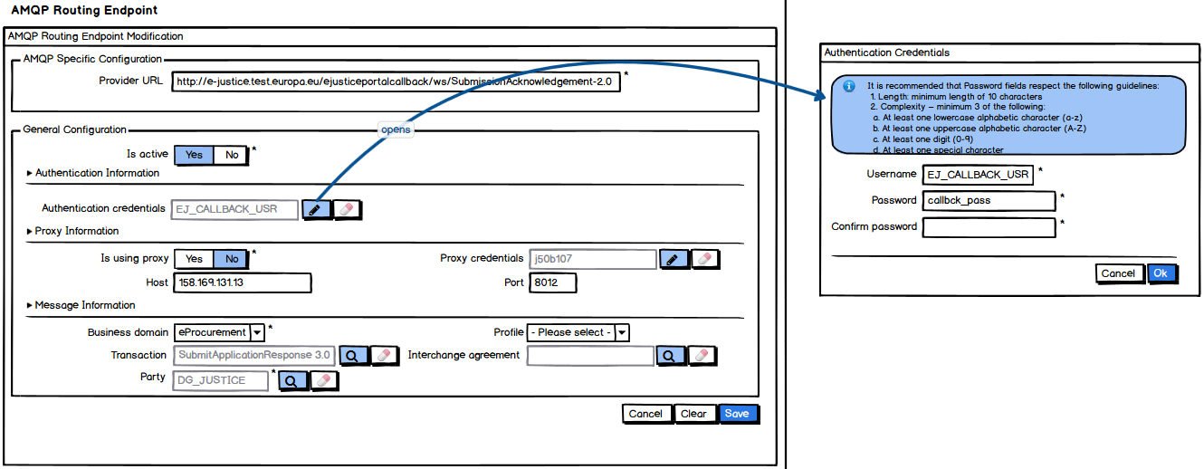

"Delete Endpoint Configuration" page
